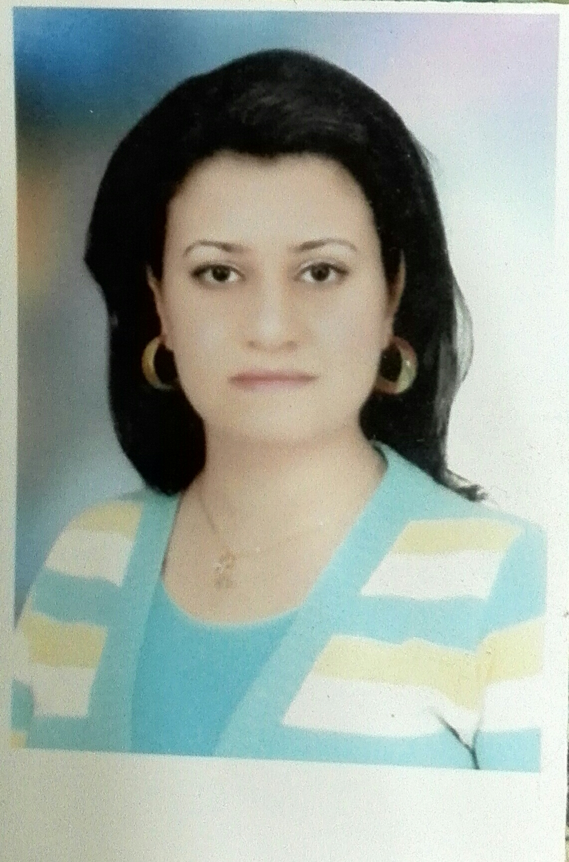
Mariana Kamal Goda
01225704189
marianakamal @yahoo.com
Personal Information
- Place of birth : Sohag
- Date of birth : 17/7/1989
- Marital status : Married
Education
- Internship in Assiut University Hospital (2012-2013)
- Bachelor of Medicine and Surgery ( 12-2012 ) Faculty of Medicine , Assiut University

experience
- Working as a Demonstrator in Biostatistics and Cancer Epidemiology Department , South Egypt Cancer Institute , Assiut University

courses and certificates and workshop
- Infection Control (4 – 2013)
- Ethical , law & Administrative consideration in Medical Practice (4 – 2013)
- Cardio – pulmonary Resuscitation ( C. P . R ) (4 – 2013)
- Basic Surgical Skills (4 – 2013)
- Microsoft Word Training Course ( 3 – 2014 )
- Data Management and Statistical Analysis using SPSS Program ( 8 – 2014 )
- Credit Hour System Training Program ( 12 – 2014 )
- Code of Ethics Training Program (12 – 2014 )
- Communication Skills ( 12 – 2014 )
- Research Ethics ( 3 – 2015 )
- Legal and Financial Aspects in University Environment ( 4 – 2015 )
- Introduction to Medical Statistics with the Use of SPSS Package ( 4 –2015)
Languages
- ARABIC : Native Language .
- ENGLISH : Fluent (written , spoken ) .

Conferences Attended
- 6th Annual Scientific Conference of South Egypt Cancer Institute ( 4 – 2014 )
- Tissue Culture and Molecular Biology Student Project Scientific Conference ( 4 – 2015 )

